Hong Kong Institute of Vocational Education (Tsing Yi)
Department of Information and Communications Technology
HD in Game Software Development (IT114107)

ITP4913M Final Year Project
(2019/2020)

Spector City
A Horror but puzzling game

Supervisor: | Albert YF Ho
Co-supervisor:
Student: | Lam Wang Yu  Wu Man Kit  ZhangYao Hui  Chan Chiu Shun

We declare that this is a group project and that no part of this submission has been copied from any other student’s work or from any other source except where due acknowledgement is made explicitly in the text, nor has any part been written for us by another person.

Student | Contribution to the project (%)  (Total 100%) | Signature
Lam Wang Yu
Wu Man Kit
ZhangYao Hui
Chan Chiu Shun

ABC City

Abstract

This project is about a horror and puzzling game, namely Spector City.
This is a Single-player, VR supported game which emphasis on multi-route and horror atmosphere.

Table of Content
Abstract 3
Introduction 5
Game Design 6
Game Overview 8
Game World 10
Objects 13
Gameplay Description 15
Hardware Requirements 18
Software Requirements 19
Technical Consideration 19
Project Plan (Sept 19 – May 20) 20
References 22
Appendices 23
Budget Estimation 24
Log Sheet 27

Introduction
This game is about our main character Leo, who born in the conflicts between human and ghost. The goal of the game is to defeat ghosts by different method. This is a 3D action and adventure game on PC platform that support VR device additionally. The player can choose difficulty and play in single-player-mode.

This report covers the basic consideration of the game design including constraints, requirements, marketing etc. This document includes all major aspect of this game design as well, such as game story, environment, level of design, maps, character and object design, user interface design. Moreover, it covers the play mode, audio and visual requirements of the game by a list. In addition, this document specifies the platform and requirements for both playing and developing the game specifically the hardware and software requirements. Finally, it mentions the project management related issue such as the project plan, resources required and the budget estimation.

By reading this document, programmers and game artists of development team should be able to work independently on their assigned tasks and testers should be able to prepare a complete test plan for testing the game.

Game Design
Constraints & Requirements
Time Limit | To be finished in 8 months
System Architecture | Client-Database
Playstyle | Keyboard mode/ VR mode
Programming Language | C# Visual Studio

User Experiences
Most of the horror and puzzling game defines what users should do in order to move to next level. That means the move, or the actions taken are limited. Games like that usually feels repetitive and predictable.

Insight
We should not limit the route of the game and provide a chance of showing creativity to players. After discussions, two solutions were drawn:

- Open-World & MMO Setting
- Single Player & VR Controller

Eventually, we chose option 2 since VR device can enhance the horror atmosphere and provide better immersion. Although with Single player mode, we could not provide as much route for players, but option 1 requires more resources on networking and server resources, which means more budget is needed.

Unique selling point
We are not only selling the scary story. The game also has room escape provide to any player. Besides, we are setting the “Ghost eyes” perspective. In these chapters, the player needs to switch the perspective to “Ghost eyes” and use that to find the way out.

There are also provide many items. But in case, the player does not have enough item. That is mean the player needs to rely upon branch task to improve the character as stronger.
(not done yet by Kit)

Game Overview
Story Background
In the area of HK, the third governmental established an organization. It is for the deal with any special case. Even ghosts harm the human on another side.

Somebody trusts that the world has two space. The main one is for human. The second one is for unknown object. However, Leo has a skill it can through to the second space. Leo’s father was said, “great power comes with great responsibility”. Therefore, Leo joins the organization. He wishes he can use that skill to support the organization.

(booked by Kit)

Play modes
Specter City just has Single Player mode. When the player completes the mission. Player will get the reward and qualified to next level. When the player complete special conditions. Player will get the achievement. Most condition of achievements is hiding. Players need to explore slow though playing. Player can watch the opening achievements in the lobby. If the player is not able to complete the mission. The next level cannot open. Player need to thing strategy to complete the mission.

System Architecture
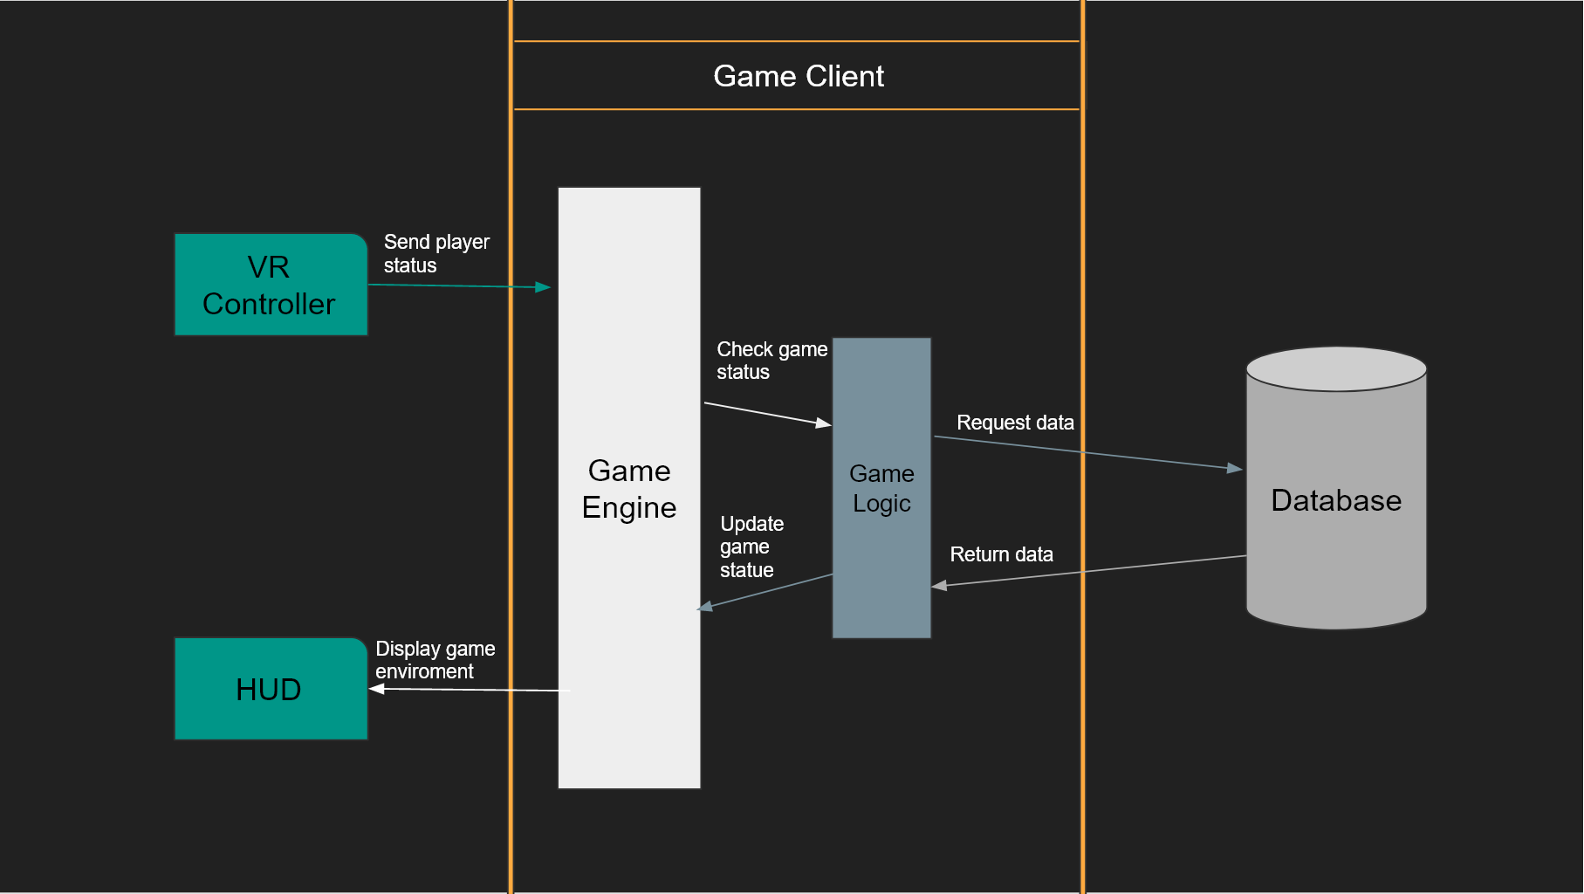

Game World
Game Environment
The game takes place in environments full of undead. There are 3 levels and each level are in other places in the world. The detail game environment of each level is shown in the level design below. The game world has a different character for example undead and ghost. There will be further exhaustive in the character and Object Design section.

Level of Design
The game will have three levels. At least 3 difficulty levels per level. Monsters at different levels have different properties. Players need to fight with props and weapons. When the level is more difficult. Players need to understand the game better.

Characters
Player---Leo
He had been fond of hearing his father's ghost stories ever since he was a child. prefer to be access to ghosts. He has been studying the stories of ancient ghosts.
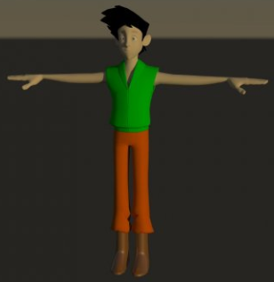

NPC--- Anaya
The background is unclear. I heard that I was a fighter. I don't know what happened. Now I am the receptionist of the base.
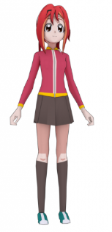

Ghost
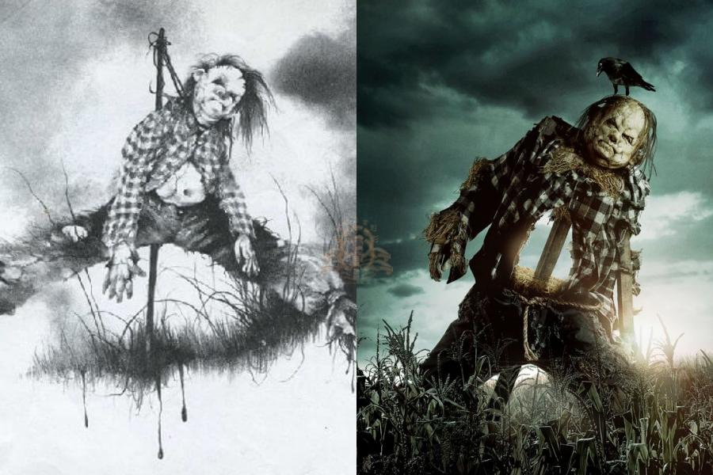

Objects
Key Items

When a player plays this game. The player will meet a different door. The player needs to find some of the key items to open the door and continues the adventure.

Keys
Red Key | Player need use mysterious power look for the key. Use to open some doors.
Green Key | Use to open normal doors.

Mysterious Power

When a player plays this game. The player will meet different problem. The player needs use this item to watch another world find clues for solve the problem.

List of Mysterious Power:
Item Name | Description
Mysterious Power | Use to look for other clues.

Weapons

Weapons are used to attack ghosts. Choose the right weapons to obtain the optimal.
Weapon
Sword | Give damage to enemy.
Stick | Give damage to enemy.

Consumable Item

Consumable items work in specific situations. Players will need to utilize them wisely.
Consumable Item
Ice Bomb | Slow down the enemy.

Gameplay Description
How to interact
Our game is a single player. So, the interact is only with NPC. The main interact between the player and NPC is to receive the task, get the content of the task and complete the task. For example, when player receive the task NPC will say something encouraging and when player complete the task NPC will say thank you.

User Interface Design
Game menu
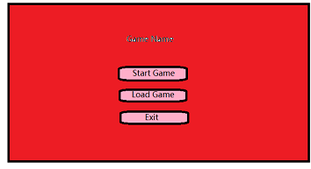
This a Game menu. Player can start game, load game and exit the game.

Normal UI
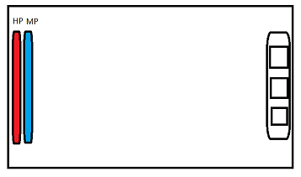
This a Player UI. Player can see Hp and Mp.

Load UI
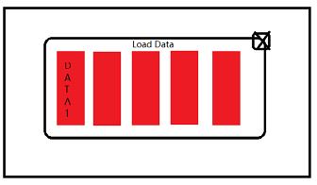
This a Load Data UI. Player can choose the data.

Mission UI
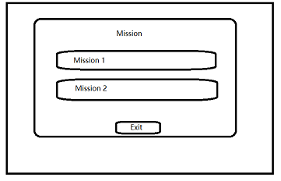
This Mission UI. Player can choose the mission.

Control

Button | Use | Function
Trigger | 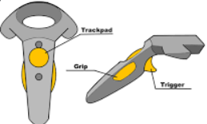 | Player can move forward.
Trackpad |  | Player can change item.
Grip |  | Player can use item.

Hardware Requirements
Recommended Requirement of Playing the game
Input Devices | Mode 1 | Keyboard and mouse
Input Devices | Mode 2 | VR device and HTC controller
PC Specification | Processor |  | Intel® Core™ i5 or above
PC Specification | RAM |  | 4.00GB or above
PC Specification | Graphic Card |  | GeForce GTX 960 or above
PC Specification | Storage |  | 2GB of above

Minimal Requirement of Playing the game
Input Devices | Mode 1 | Keyboard and mouse
Input Devices | Mode 2 | VR device and HTC controller
PC Specification | Processor |  | Intel® Core™ i3 or above
PC Specification | RAM |  | 2.00GB or above
PC Specification | Graphic Card |  | GeForce GTX 750 or above
PC Specification | Storage |  | 2GB of above

Hardware Requirement of Development
Input Devices | Mode 1 | Keyboard and mouse
Input Devices | Mode 2 | VR device and HTC Vive controller
PC Specification | Processor |  | Intel® Core™ i7 or above
PC Specification | RAM |  | 8.00GB or above
PC Specification | Graphic Card |  | GeForce GTX 1060 or above
PC Specification | Storage |  | 2GB of above

Software Requirements

Software Requirement
Operation System | Window 10 32-bit/ 64bit
3D Modeling | 3Ds MAX 2016 or above
Game Engine | Unity 2018 or above
Database | Microsoft Access

Technical Consideration

Technical Consideration
Programming Language | C#

Project Plan (Sept 19 – May 20)
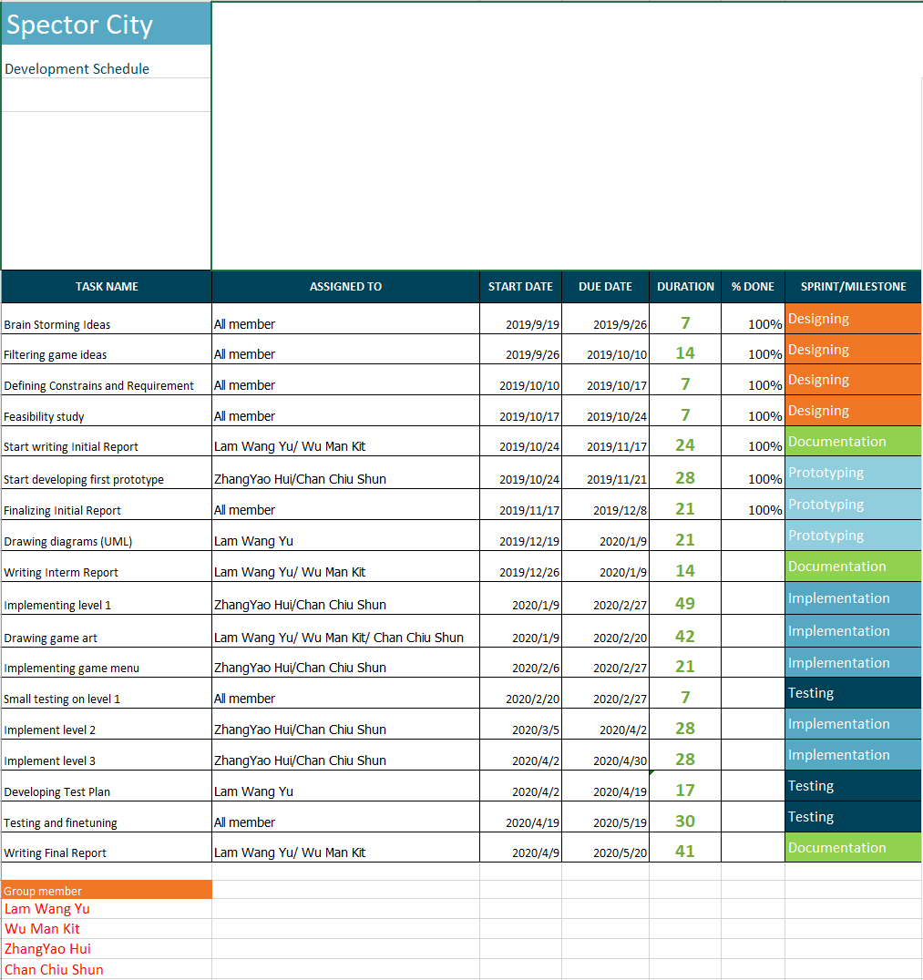
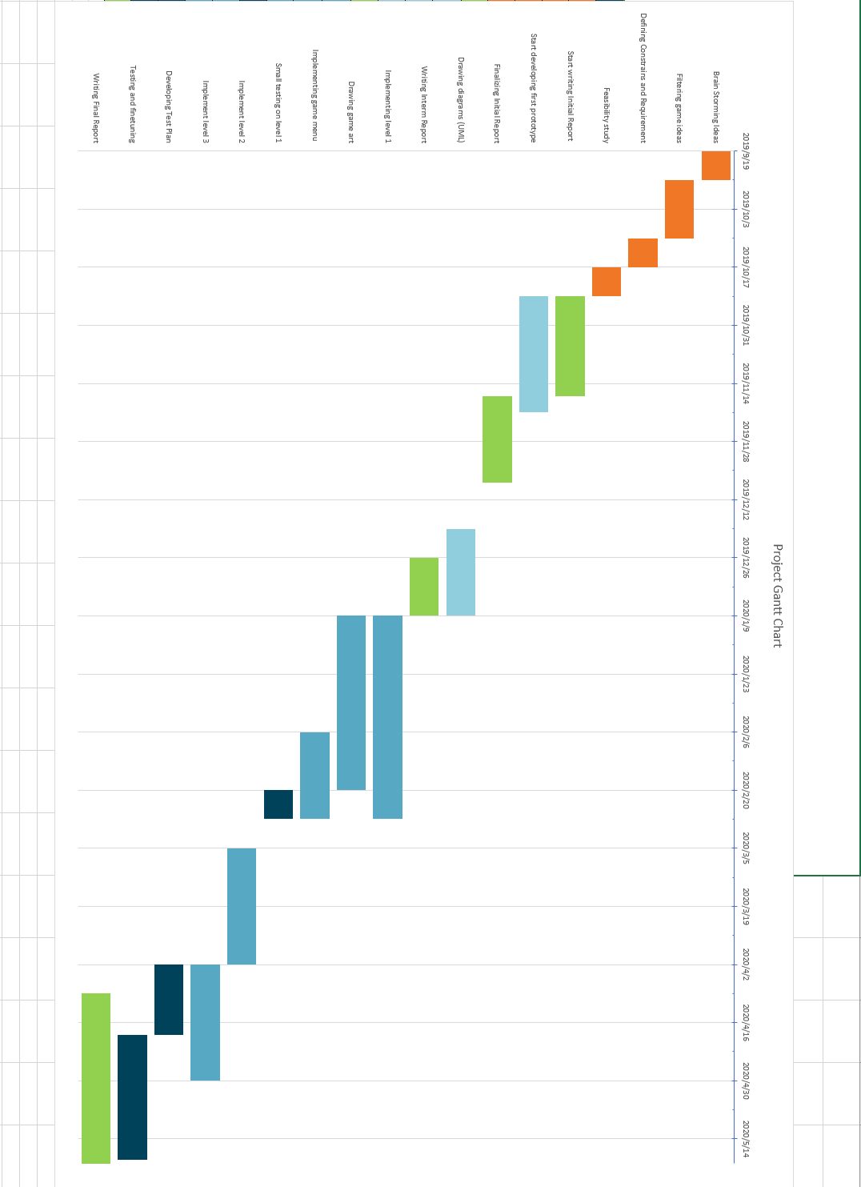
Milestone description
First Prototype | 2019/10/24-2019/11/21
Completing UML diagram | 2019/12/19-2020/1/9
Implementing level 1 | 2020/1/9-2020/2/27
Implementing level 2 | 2020/3/5-2020/4/2
Implementing level 3 | 2020/4/2-2020/4/30

Action plan for the prototypes
1 | Using C# Dictionary for storage system
2 | Try implementing enemy AI
3 | Implement Mysterious Power

References
https://www.price.com.hk/
https://free3d.com/zh/3d-model/anime-character-917535.html
https://free3d.com/zh/3d-model/boy-3d-model-88773.html
https://ddm.com.tw/blog/post/scary-stories-to-tell-in-the-dark-stories

Appendices
Workload Distribution
UI design | Wu Man Kit, Lam Wang Yu,  ZHANG Yaohui, Chan Chiu Shun
3D model | Wu Man Kit,
Document | Wu Man Kit, Lam Wang Yu
Story | Wu Man Kit, Chan Chiu Shun
Game Programming | Lam Wang Yu, ZHANG Yaohui,  Chan Chiu Shun
Map and build design | ZHANG Yaohui
Mission design | ZHANG Yaohui

Budget Estimation

Recommended Requirement
Input device
-keyboard | $40
-mouse | $15
- VR device | $4899
- HTC controller | $1087
PC Specification
- processor | $1050
-ram | $168
- graphic card | $1730
total | $8980

Minimal Requirement
Input device
-keyboard | $40
-mouse | $15
- VR device | $4899
- HTC controller | $1087
PC Specification
- processor | $409
-ram | $135
- graphic card | $960
total | $7545

Hardware Requirement
Input device
-keyboard | $40
-mouse | $15
- VR device | $4899
- HTC controller | $1087
PC Specification
- processor | $2290
-ram | $255
- graphic card | $1999
total | $10585

Software Requirement
- Operation System | $1018
total | $1018

Log Sheet

